TEST PLAN

CURA Healthcare Service

https://katalon-demo-cura.herokuapp.com/

Table of Contents

* Overview ---------------------------------------------------------------- 2
* Scope -------------------------------------------------------------------- 2
* Inclusion ------------------------------------------------------ 3
* Exclusion ----------------------------------------------------- 3
* Test Environment ------------------------------------------- 3
* Test Strategy ------------------------------------------------------------ 3-4
* Test Tracking Procedures --------------------------------------------- 5
* Test Schedule ----------------------------------------------------------- 5
* Test Deliverables-------------------------------------------------------- 6
* Entry and Exit Criteria ------------------------------------------------- 6-7
* Tools ---------------------------------------------------------------------- 7
* Risks and Mitigation ---------------------------------------------------- 7
* Approvals ----------------------------------------------------------------- 8

OVERVIEW

As a part of this Project, CURA Healthcare Service a demo app <https://katalon-demo-cura.herokuapp.com/> Functionalities are being Tested

This Document Serves As Test Planning Document With Details On The Scope Of The Project, Test Strategy, Test Schedule And Resource Requirements, Test Deliverables And Schedule, Defect Tracking Procedure.

SCOPE

The Features and Functionality of CURA Healthcare Service App Will Be Tested,

The Types Of Testing That Will Be Performed, Such As Manual Testing, Exploratory Testing, GUI Testing.

The Environments In Which Testing Will Be Conducted, Such As Different Browsers, Operating Systems, And Device Types.

The Roles and Responsibilities of the Team Members Involved In the Testing, Such As the Test Lead, Testers, and Developers.

The Schedule and Milestones for the Testing, Including the Start and End Dates, and the Planned Testing Activities.

The Tools and Equipment That Will Be Used For Testing, Such As Testing Software, Hardware, and Documentation Templates.

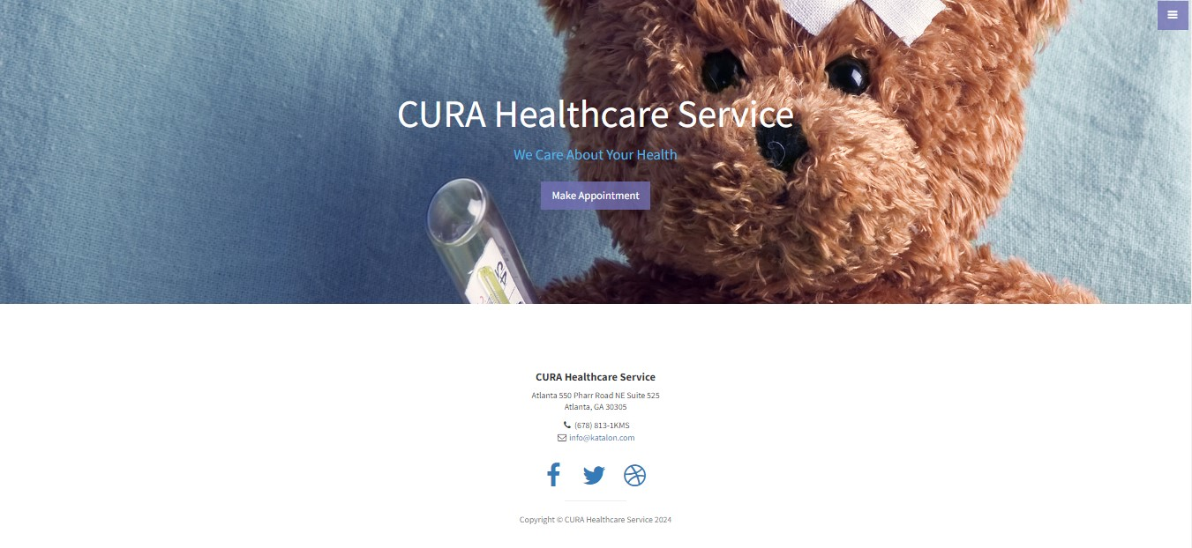

INCLUSIONS

This section would provide an overview of the test plan, including its purpose, scope, and goals.

* Login
* Make Appointment
* History
* Profile
* Home
* Logout
* Go to Homepage

EXCUSIONS

* Test Automation
* Features Apart from Inclusions.

TEST ENVIRONMENT

* Theoperating systems and versions that will be used for testing, such as Windows 10, mac OS, or Linux, Android
* The browsers and versions that will be tested, such as Google Chrome, Mozilla Firefox, or Microsoft Edge.
* The device types and screen sizes that will be used for testing, such as desktop computers, laptops, tablets, and smartphones.
* The network connectivity and bandwidth that will be available for testing, such as Wi-Fi, cellular, or wired connections.
* The hardware and software requirements for running the test cases, such as a specific processor, memory, or storage capacity.

TEST STRATEGY

Understood that we need to perform Functional Testing of all the functionalities mentioned in the above Scope section.

As part of Functional Testing, we will follow the below approach for Testing:

Step#1 – Creation of Test Scenarios and Test Cases for the different features in scope.

* We will apply several Test Designing techniques while creating Test Cases
  + Equivalence Class Partition
  + Boundary Value Analysis
  + Decision Table Testing
  + State Transition Testing
  + Use Case Testing
* We also use our expertise in creating Test Cases by applying the below:
  + Error Guessing
  + Exploratory Testing
* We prioritise the Test Cases

Step#2 – Our Testing process, when we get an Application for Testing:

* Firstly, we will perform Smoke Testing to check whether the different and important functionalities of the application are working.
* We reject the build, if the Smoke Testing fails and will wait for the stable build before performing in depth testing of the application functionalities.
* Once we receive a stable build, which passes Smoke Testing, we perform in depth testing using the Test Cases created.
* Multiple Test Resources will be testing the same Application on Multiple Supported Environments simultaneously.
* We then report the bugs in the ‘JIRA’ bug tracking tool and send you the defect found on that day as a status end of the day via email.
* As part of the Testing, we will perform the below types of Testing:
  + Smoke Testing and Sanity Testing
  + Regression Testing and Retesting
  + Usability Testing, UI Testing and Accessibility Testing
* We repeat Test Cycles until we get the quality product.

Step#3 – We will follow the below best practices to make our Testing better:

* Context Driven Testing – We will be performing Testing as per the context of the given application.
* Shift Left Testing – We will start testing from the beginning stages of the development itself, instead of waiting for the stable build through exploring the application and documents
* Exploratory Testing – Using our expertise we will perform Exploratory Testing, apart from the normal execution of the Test cases.
* End to End Flow Testing – We will test the end-to-end scenario which involve multiple functionalities to simulate the end user flows.

Windows 10 – Chrome, Firefox and Edge

Mac OS – Safari Browser

Android Mobile OS – Chrome

iPhone Mobile OS – Safari

DEFECT TRACKING PROCEDURES

The criteria for identifying a defect, such as deviation from the requirements, user experience issues, or technical errors.

The **steps for reporting a defect**, such as using a designated template, providing detailed reproduction steps, and attaching screenshots or logs.

The **process for triaging and prioritizing defects, s**uch as assigning severity and priority levels, and assigning them to the appropriate team members for investigation and resolution.

The **tools and systems** that will be used for tracking and managing defects, such as a defect tracking software or a project management tool.

The **roles and responsibilities of the team members** involved in the defect reporting process, such as testers, developers, and the test lead.

The **communication channels a**nd frequencies for updating stakeholders on the progress and status of defects.

The metrics and metrics that will be used to measure the effectiveness of the defect reporting process, such as the number of defects found, the time taken to resolve them, and the percentage of defects that were successfully fixed.

Tool used for Bug tracking JIRA

TEST SCHEDULE

Following is the test schedule planned for the project –

|  |  |
| --- | --- |
| TASK | TIME DURATION |
| Creating Test Plan |  |
| Test Case Creation |  |
| Test Case Execution |  |
| Summary Report Submission Date |  |

TEST DELIVERABLES

|  |  |  |
| --- | --- | --- |
| **Deliverables** | **Description** | **Target Completion Date** |
| Test Plan | Details on the scope of the Project, test strategy, test schedule, resource requirements, test deliverables and schedule | Dates:  From  To |
| Functional Test Cases | Test Cases created for the scope defined | Dates:  From  To |
| Defect Reports | Detailed description of the defects identified along with screenshots and steps to reproduce on a daily basis. | Dates:  From  To |
| Summary Reports | Summary Reports –  Bugs by Bug,  Bugs by Functional Area and  Bugs by Priority | Dates:  From  To |
|  |  |  |

ENTRY AND EXIT CRETERIA

The below are the entry and exit criteria for every phase of Software Testing Life Cycle:

**Requirement Analysis**

Entry Criteria:

* Once the testing team receives the Requirements Documents or details about the Project

Exit Criteria:

* List of Requirements are explored and understood by the Testing team
* Doubts are cleared

**Test Planning**

Entry Criteria:

* Testable Requirements derived from the given Requirements Documents or Project details
* Doubts are cleared

Exit Criteria:

* Test Plan document (includes Test Strategy) is signed-off by the Client

**Test Designing**

Entry Criteria:

* Test Plan Document is signed-off by the Client

Exit Criteria:

* Test Scenarios and Test Cases Documents are signed-off by the Client

**Test Execution**

Entry Criteria:

* Test Scenarios and Test Cases Documents are signed-off by the Client
* Application is ready for Testing

Exit Criteria:

* Test Case Reports, Defect Reports are ready

**Test Closure**

Entry Criteria:

* Test Case Reports, Defect Reports are ready

Exit Criteria:

* Test Summary Reports

TOOLS

The following are the list of Tools we will be using in this Project:

• JIRA Bug Tracking Tool

• Light shot Screenshot Tool

• Word and Excel documents

RISKS AND MITIGATION

The following are the list of risks possible and the ways to mitigate them:

Risk: Non-Availability of a Resource

Mitigation: Backup Resource Planning

Risk: Less time for Testing

Mitigation: Ramp up the resources based on the Client needs dynamically

APPROVAL

Team will send different types of documents for Client Approval like below:

• Test Plan

• Test Scenarios

• Test Cases

• Reports

Testing will only continue to the next steps once these approvals are done